To bring stabilization to boats as small as 23 feet,
we knew we had to break the mold. The new
Seakeeper 1 features a flush mount design for
easier installation, runs exclusively on 12V DC power,
and can be installed virtually anywhere on board.

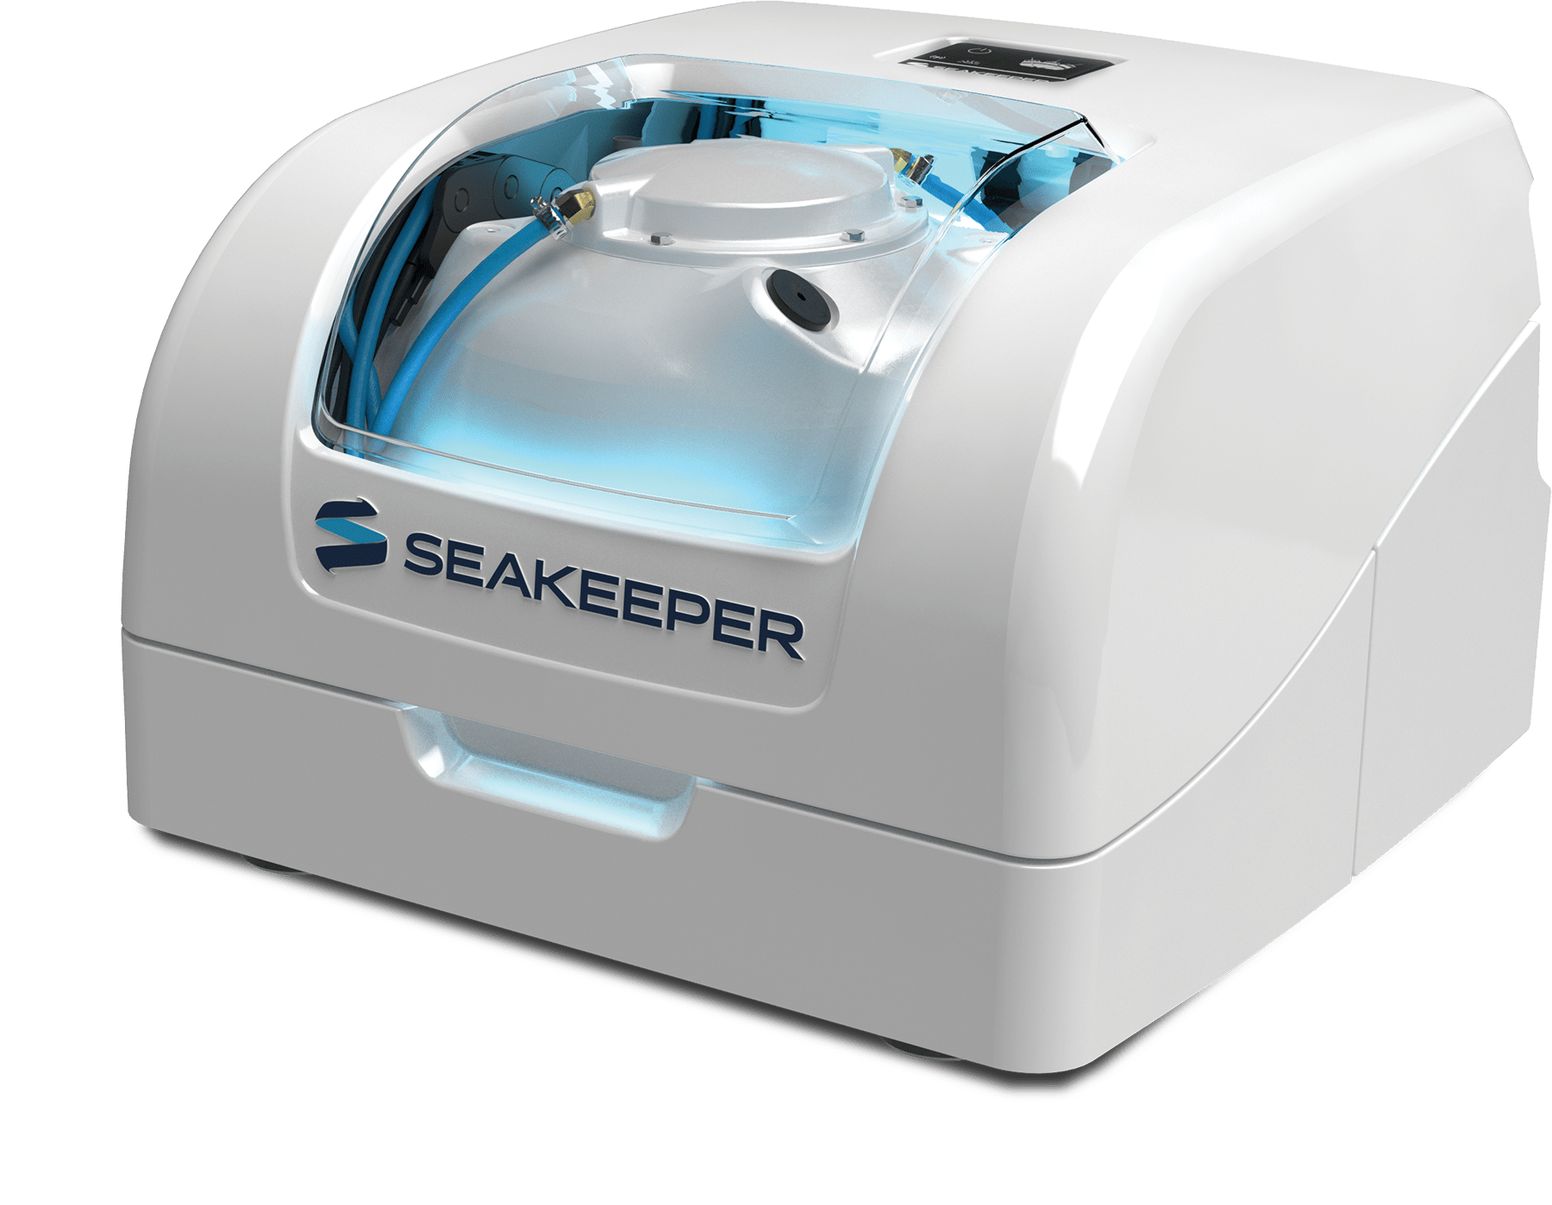
Specification
Rated Speed | 9,750 RPM
Angular Momentum at Rated RPM | 1,000 N-M-S
Max Anti-Rolling Torque at Rated RPM | 2,620 N-M
Spool-up Time to Rated RPM | 30 minutes (9,750 RPM)
Spool-up Time to Stabilization | 15 minutes (7,310 RPM)
Spool-up Power
AC Input | N/A
DC Input | 600 Watts Max
Operating Power
AC Input (sea state dependent) | N/A
DC Input | 300 - 600 Watts (Sea State Dependent)
AC Input Voltage (Single Phase) | N/A
DC Input Voltage | 12 VDC @ 55 Amps
Weight | 365 lbs (165 kg) Approximately
Envelope Dimensions | 22.9 L x 23.6 W x 15.7 H (Inches)  0.582 L x 0.598 W x 0.398 H (meters)

Drawings:
- 
 